**EXPERIMENT 6**

Create a Virtual Machine with 1 CPU, 2GB RAM and 15GB storage disk using a Type 2 Virtualization Software

1.open VM ware and click on create

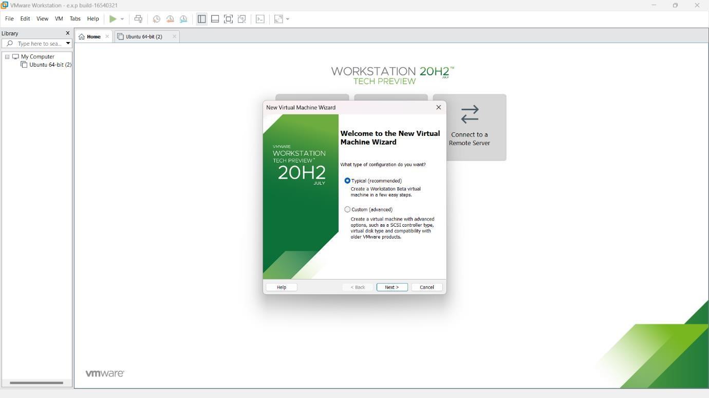

# 2.click on next 3.choose install os later

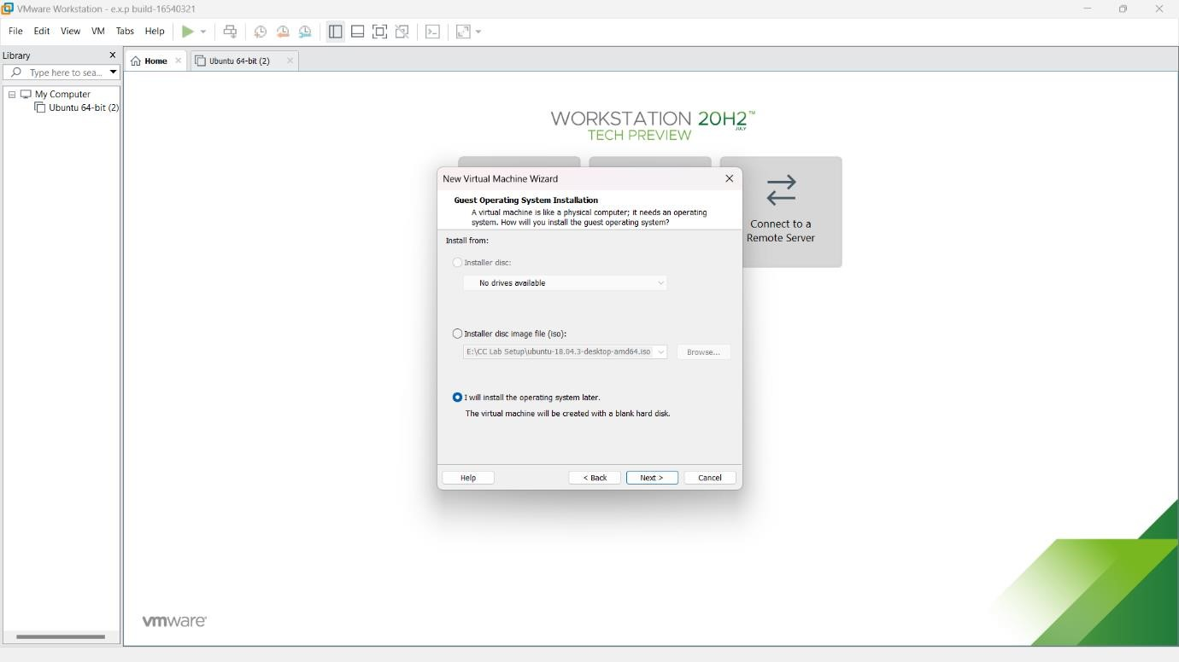

# 4.choose linux

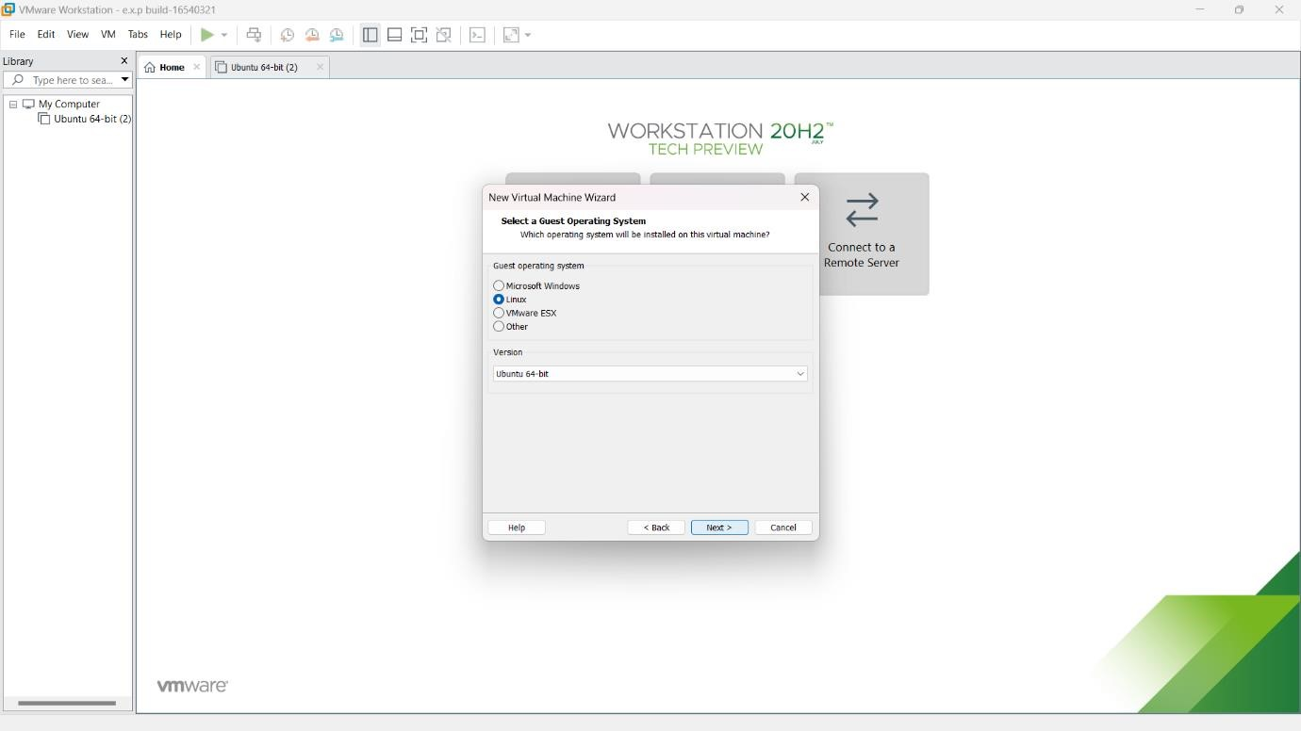

# 5.click on next

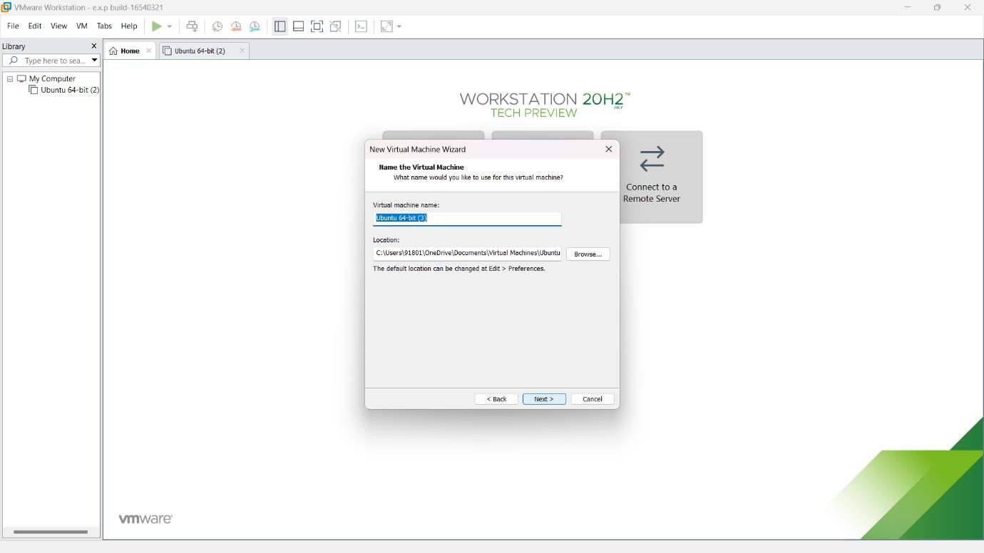

# 6.click on store as single file

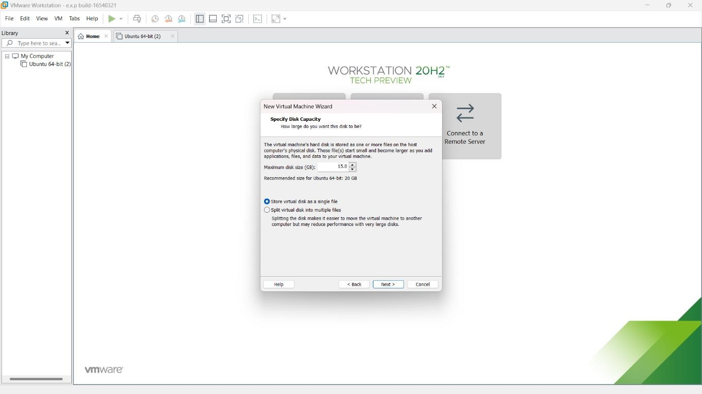

# 7.verify the details and click next

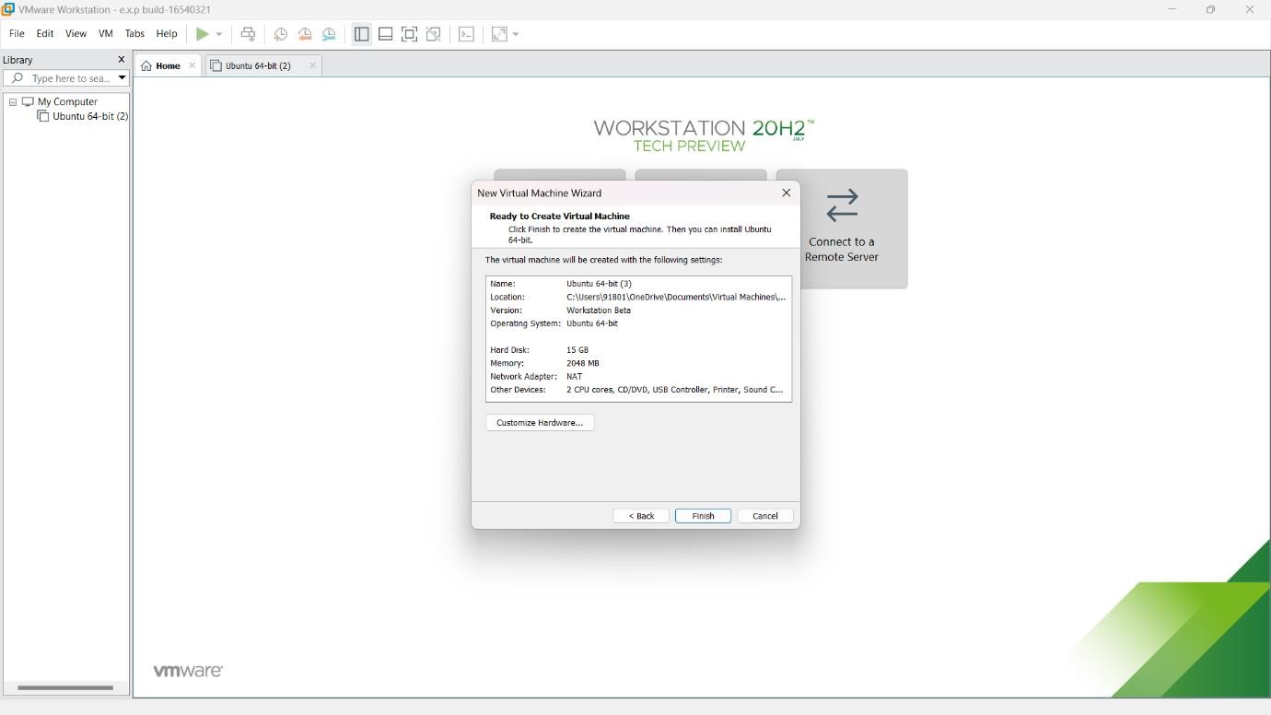

# 8.change the cpu number as required by doing double click

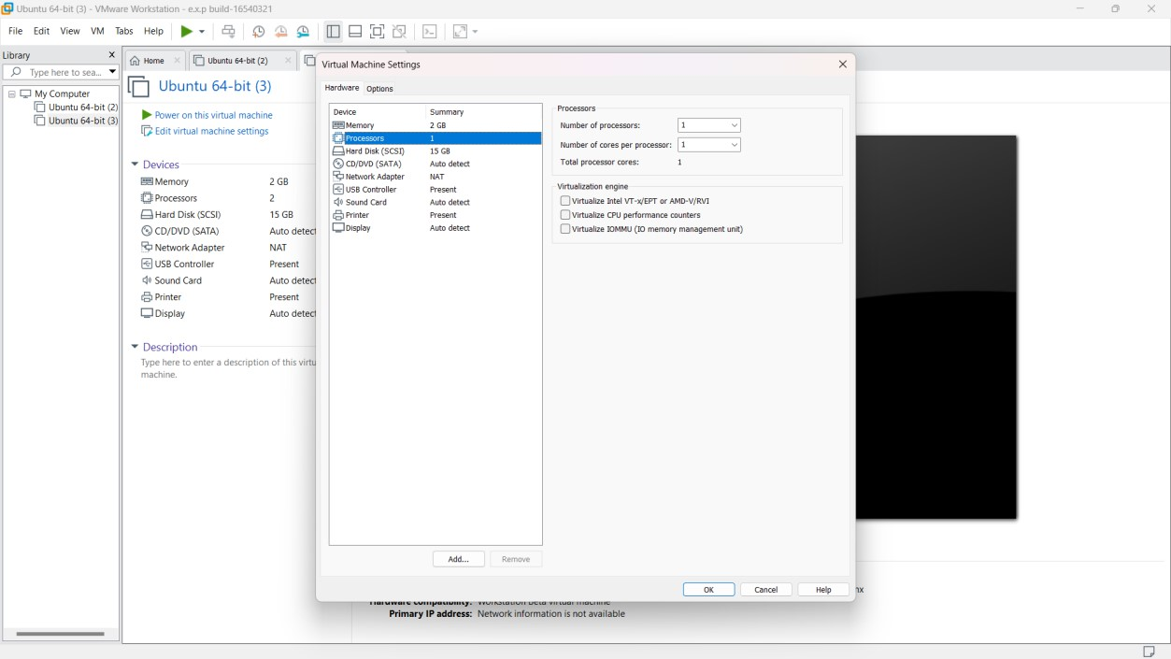

# 9.verify the details as same as required in given question

